Papers written by Australian Maths Software

SEMESTER TWO

MATHEMATICS SPECIALIST

UNITS 3-4

2017

SOLUTIONS

Section One
1. (3 marks)
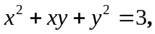
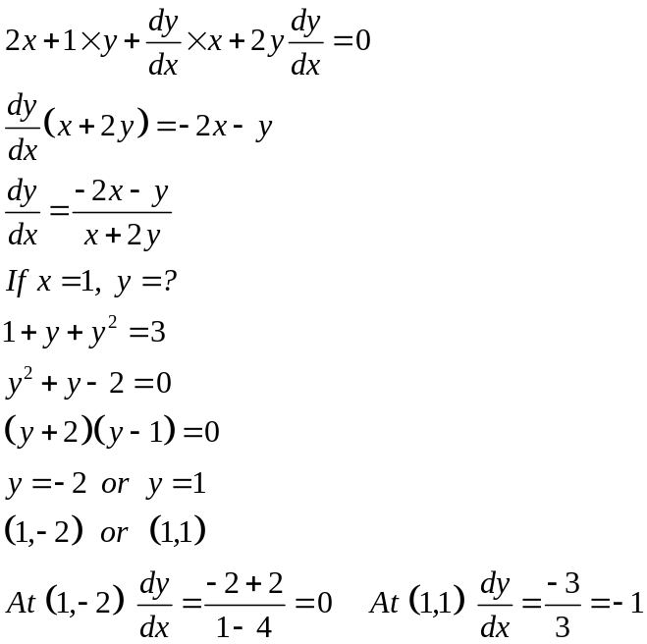
✓
✓

✓

(3)
2. (12 marks)
(a) 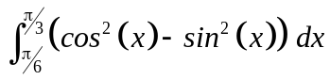
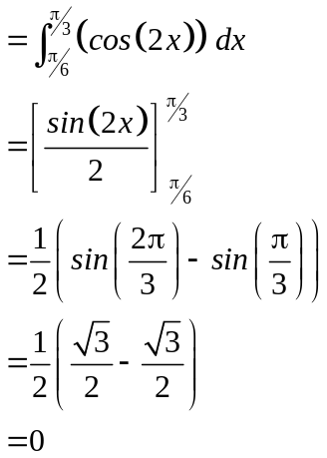
✓
✓
✓
(3)
(b) 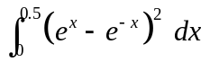
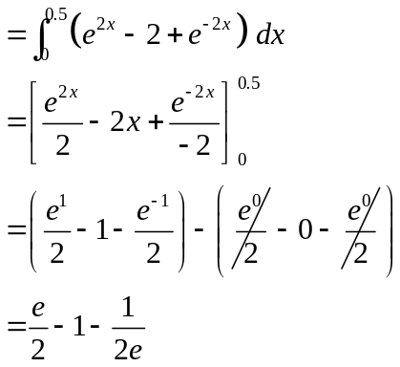
✓
✓
(2)
(c) 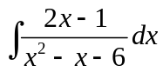
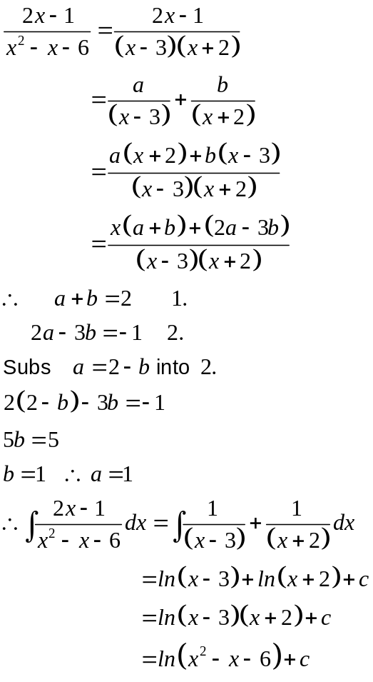
✓
✓
✓
✓
(4)
(d) 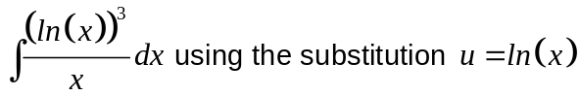
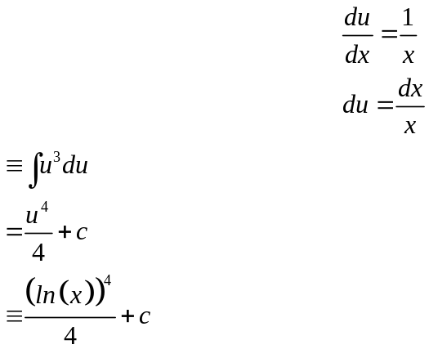
✓
✓
✓
(3)
3. (3 marks)
Express 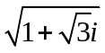 in cis form
Let 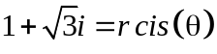
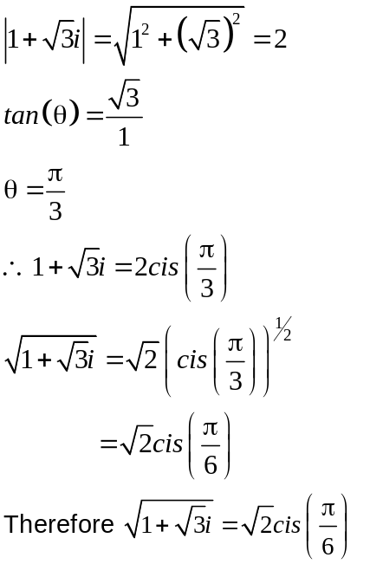
✓
✓
✓
(4)
4. (14 marks)
(a) (i) 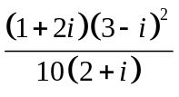
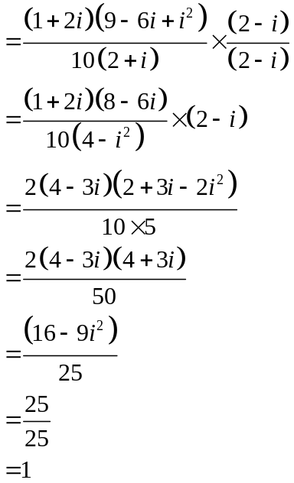
✓
✓
✓
✓
(4)
(ii) 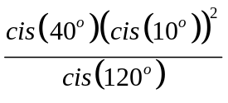
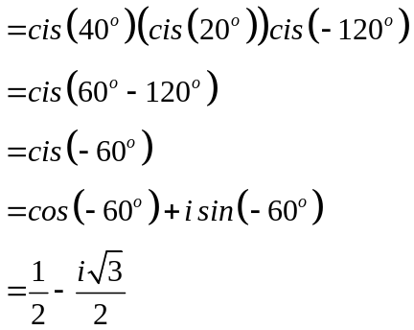 (3)
✓
✓
✓
(3)

(b) Solve for 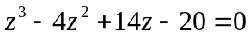.
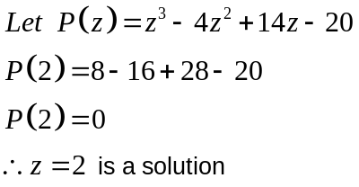
✓
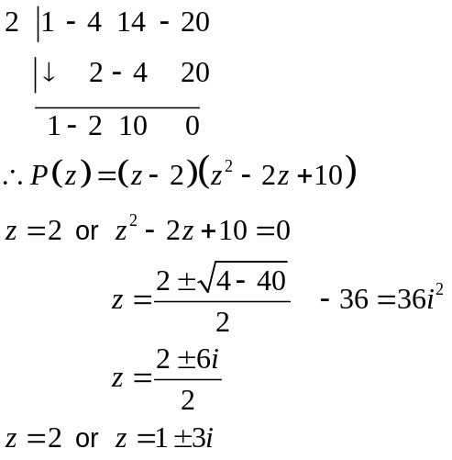
✓
✓
(3)
(c) Prove the identity
using De Moivre’s theorem.
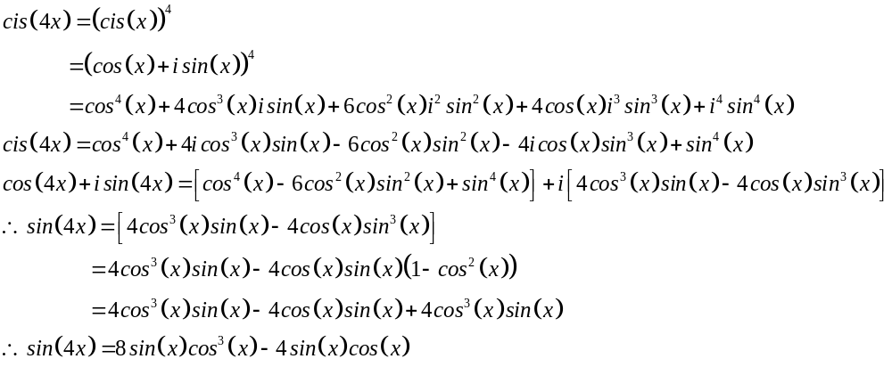 (4)
✓
✓
✓
✓
5. (7 marks)
(a) 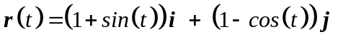
(i) Show that 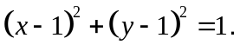
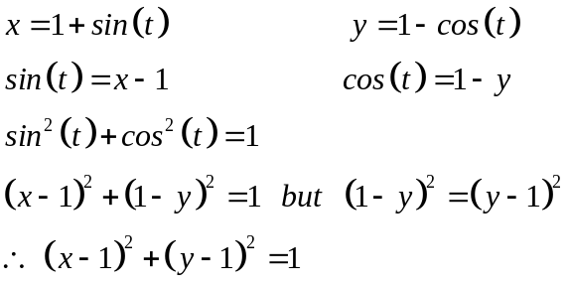
✓
✓
(2)
(ii) 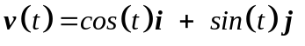
✓
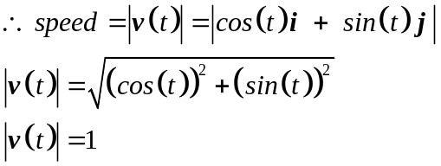
✓
(2)

(iii)
✓
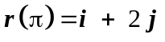
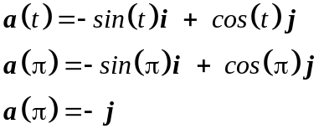
✓
✓

(3)
6. (9 marks)
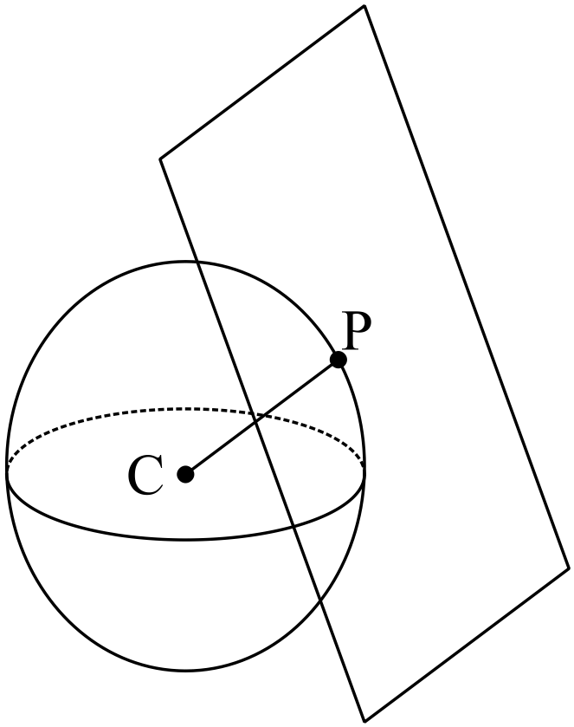 (a) (i) 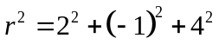
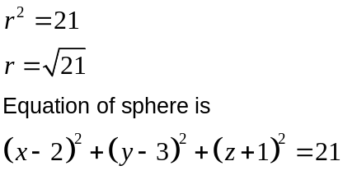
✓
✓
(2)
(ii) 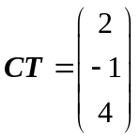
✓
✓
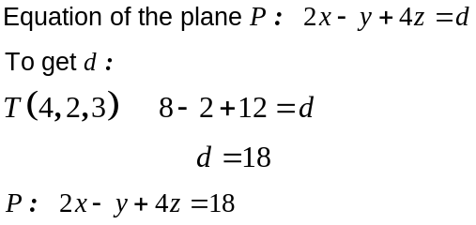
✓
(3)
(iii) Two points are 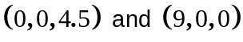 ✓✓
Answers will vary but the points must lie on the plane 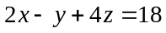.
(2)

(b) 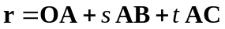
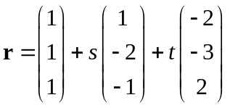
✓✓

Could be any two of 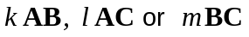

Could be any one of 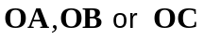

(2)

7. (4 marks)
(a) 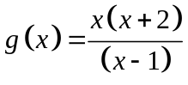

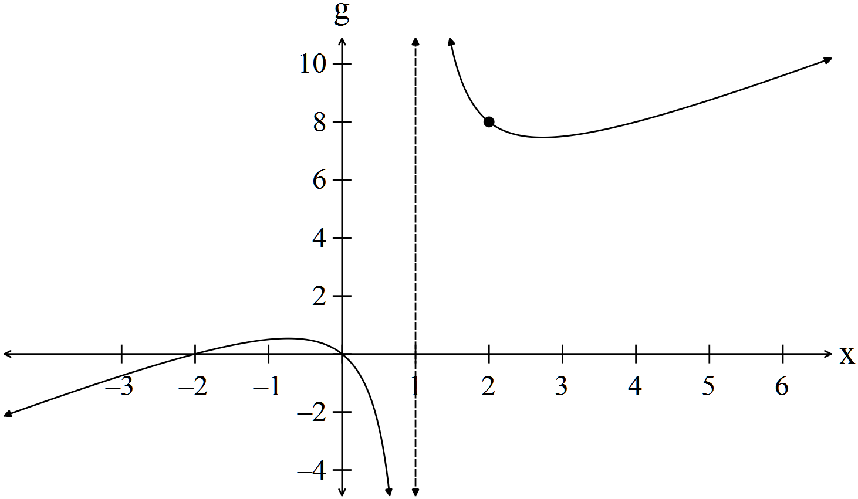
Intercepts
✓
Lim as 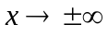
✓
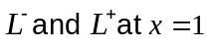 \
✓
General shape and curvature -1/error
✓
(4)

END OF SECTION ONE
Section Two
8. (6 marks)
(a) Sketch the shaded region defined by
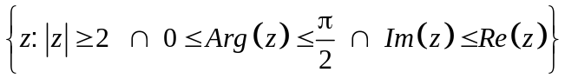
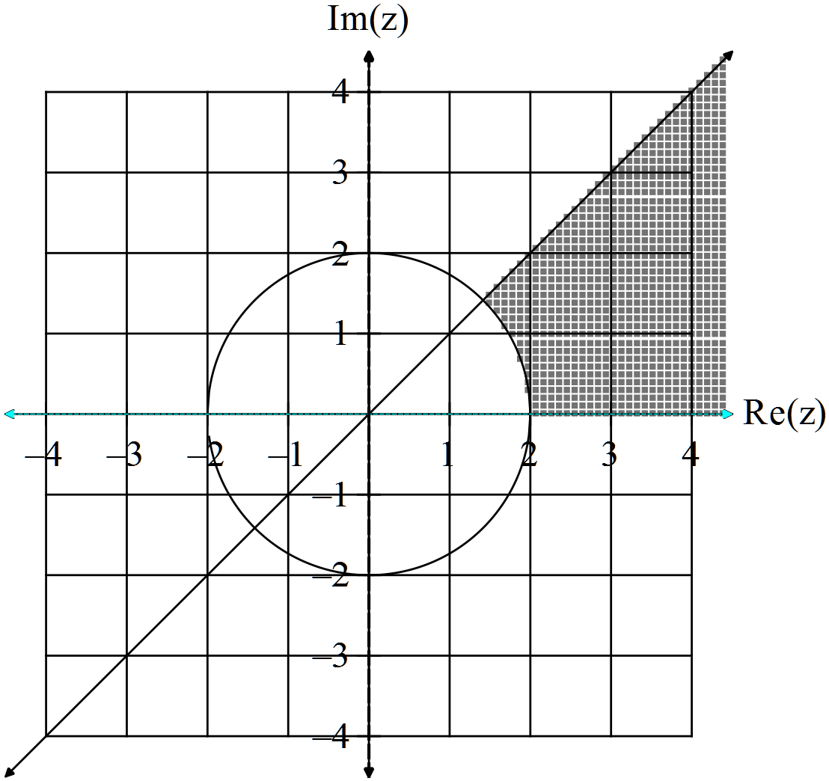
✓ Correct argument
✓ Correct line
✓ Outside circle -1/error (3)

(b) (i)
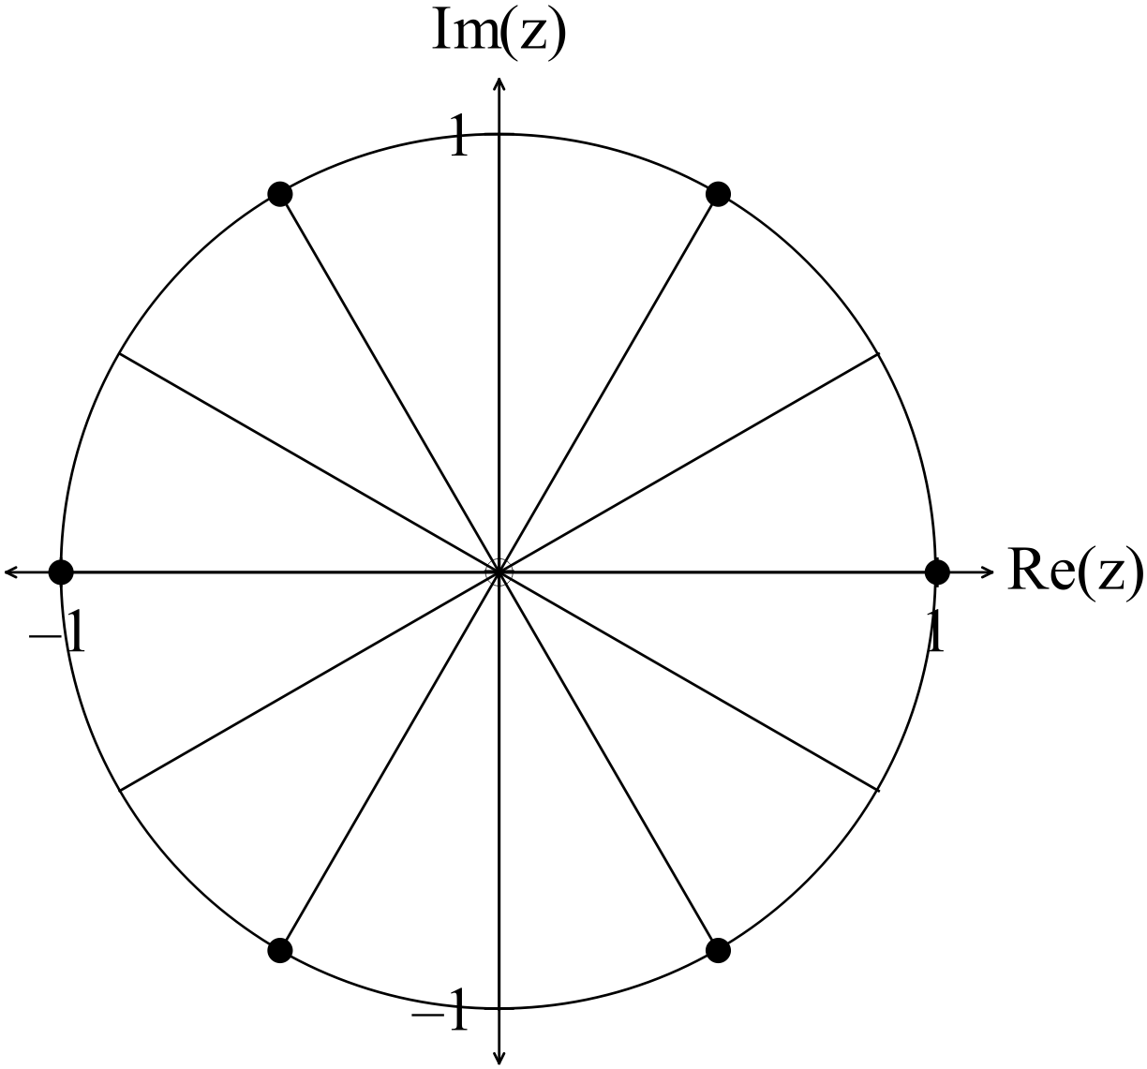✓
(1)

(ii) 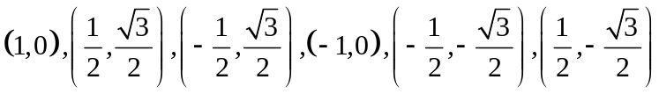 ✓ ✓ -1/error
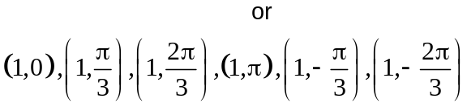
(2)

9. (3 marks)
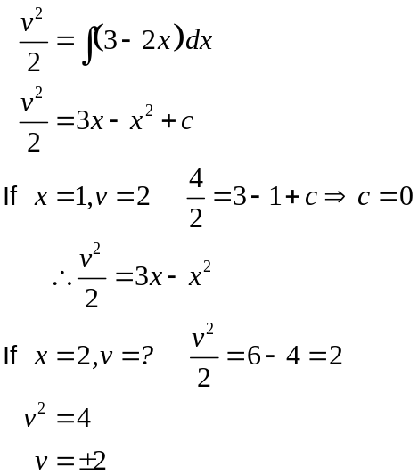
✓
✓
✓
(3)

10. (8 marks)
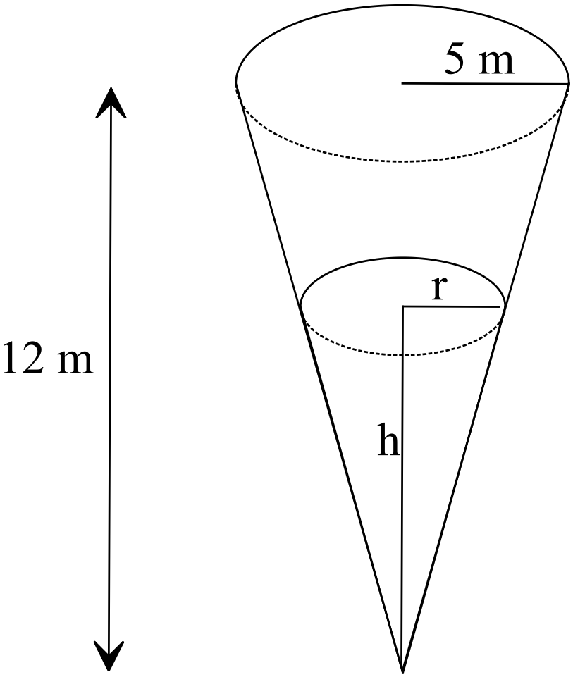
(a) 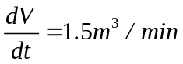
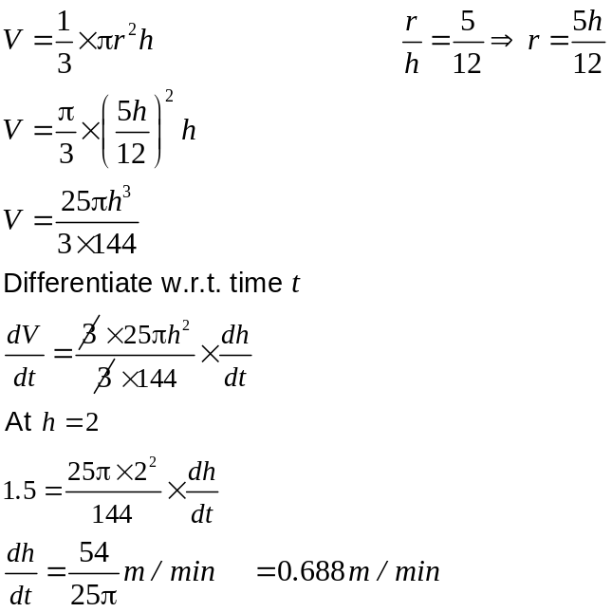
✓
✓
✓
✓
(4)

(b) 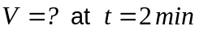
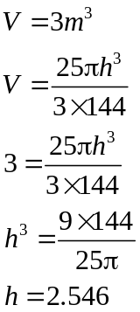 ✓
✓
(2)
(c) 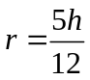
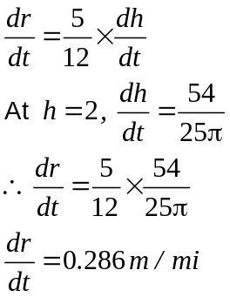
✓
✓
(2)
11. (16 marks)
(a) (i) 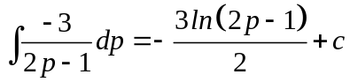 ✓✓ -1/error (2)
(ii) 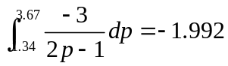 ✓✓ (2)

(b) Area = 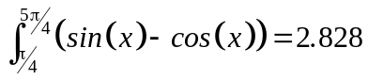
Bounds ✓
Function ✓
Answer ✓ (3)

(c)
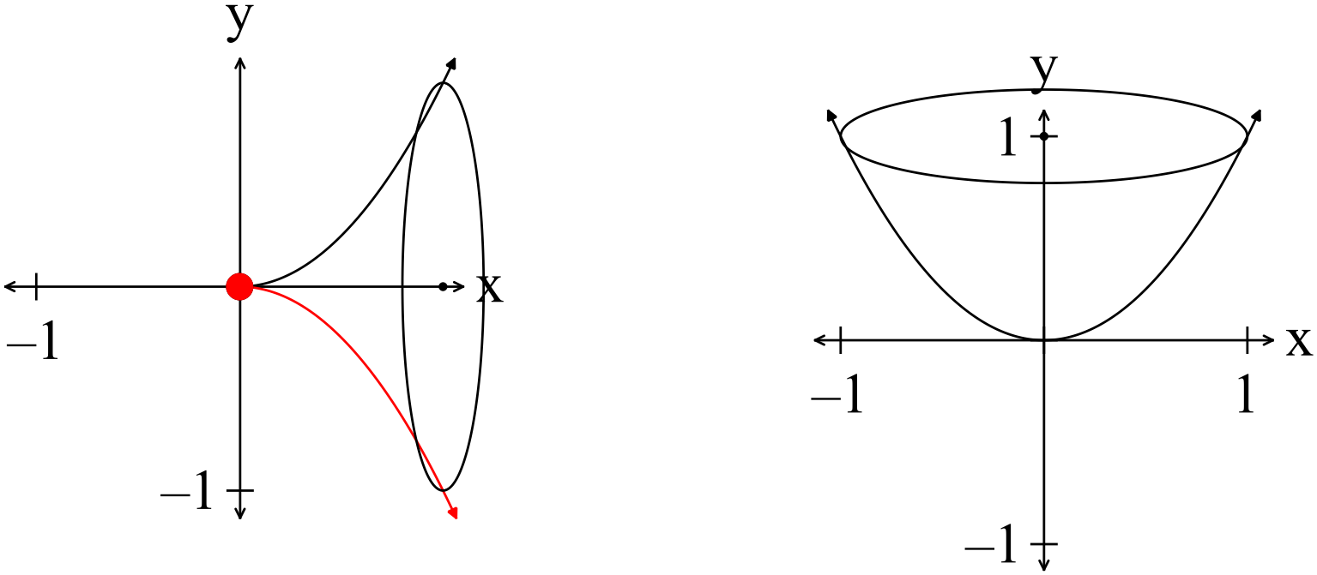
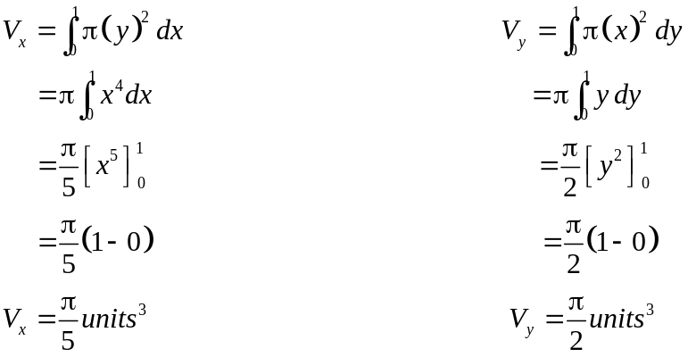
✓
✓
✓
✓
✓
Therefore 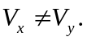 (5)
(d) 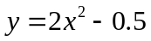 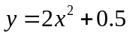
✓
If 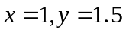 If 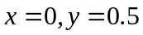 If 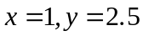;
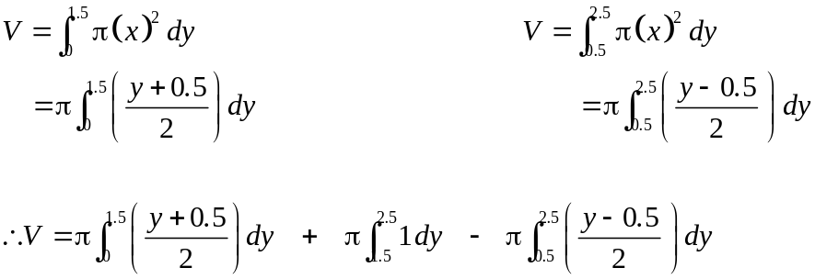
✓
✓
✓
(4)
12. (3 marks)
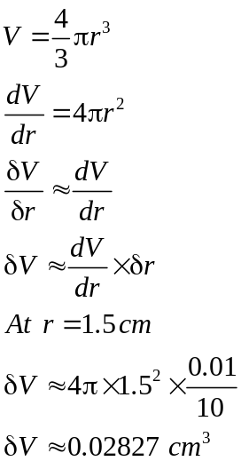
✓
✓
✓
The increase in the volume is 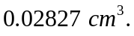 (3)
13. (18 marks)
(a) (i) 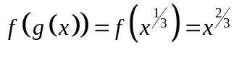
✓
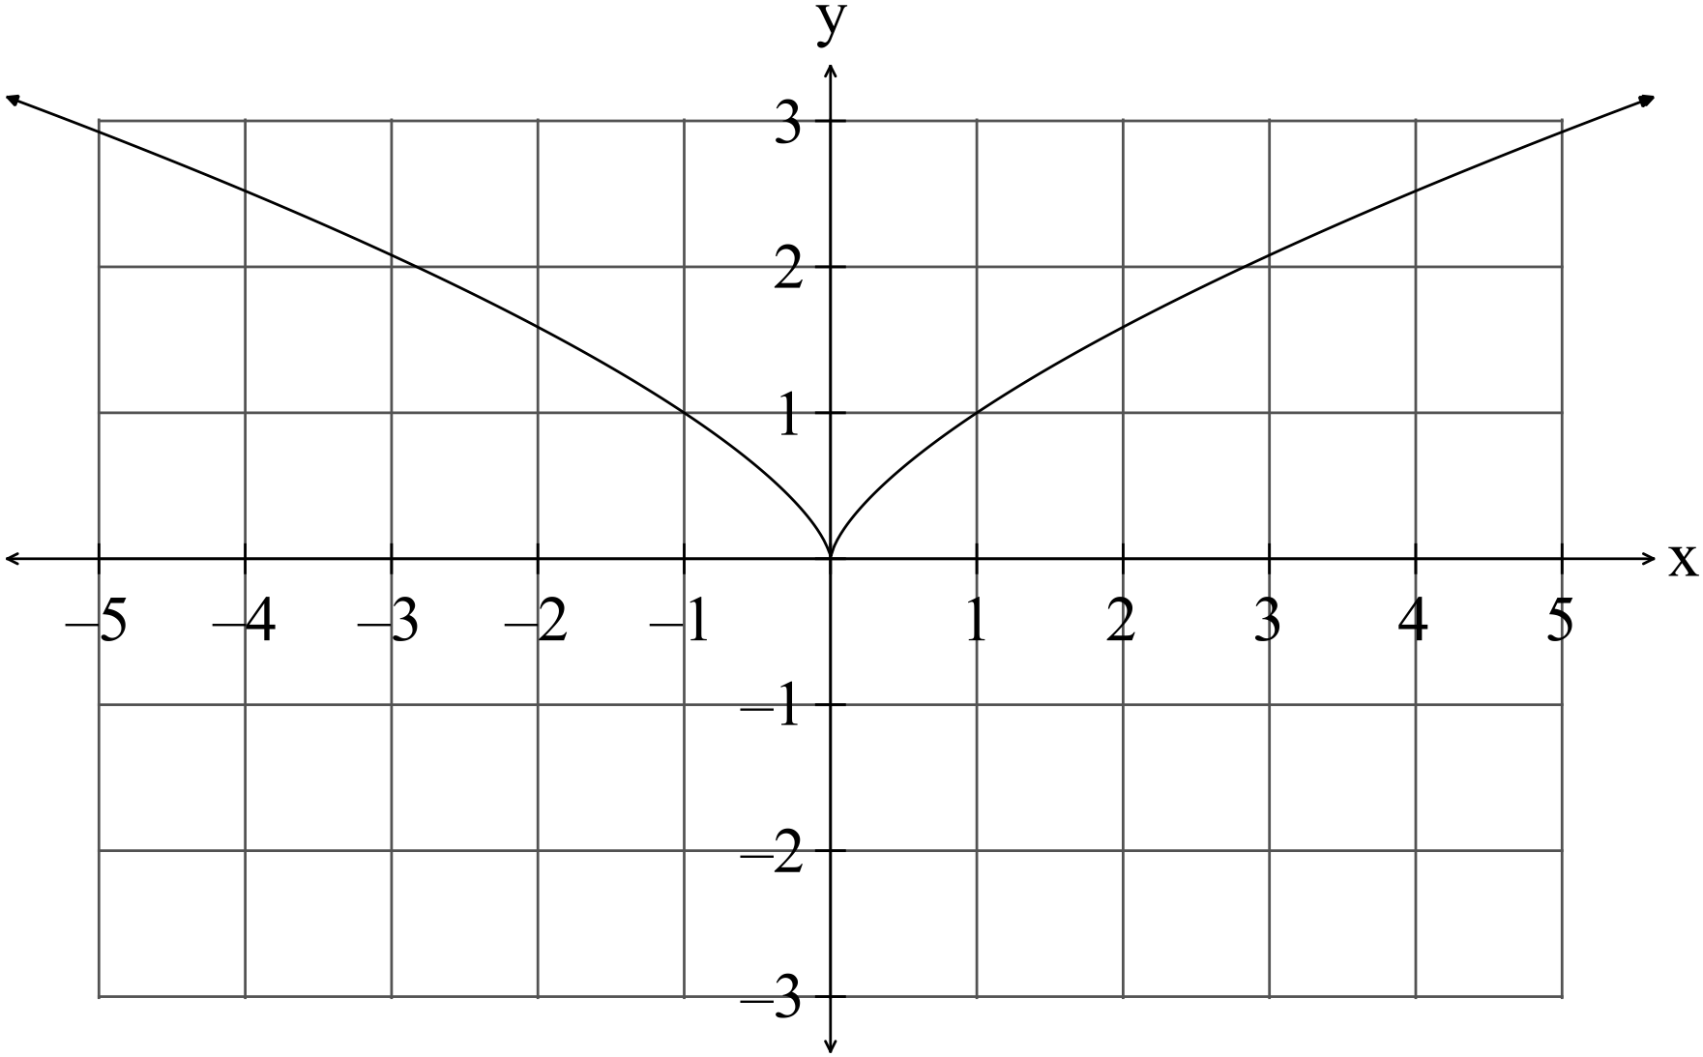
✓✓

(3)
(ii) There is no inverse function as the function 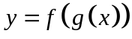 is not a one to
one function. For example if 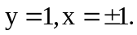 ✓✓
(2)
(iii) 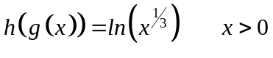 (2)
✓
✓

(b) (i)
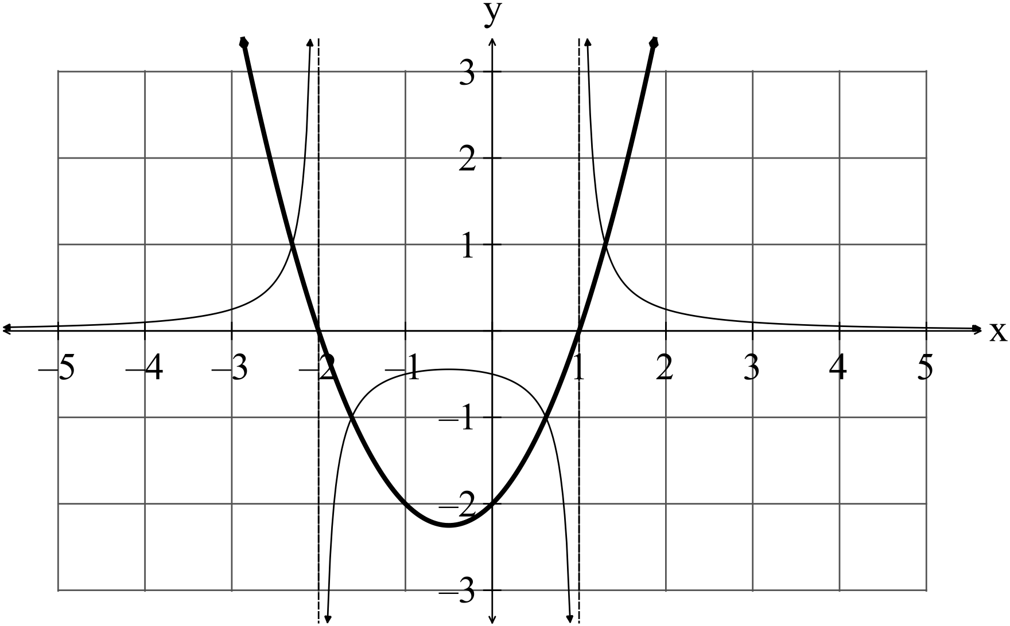
✓✓

(2)

(ii) 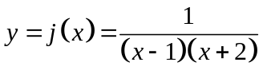 ✓✓ (2)

(iii) 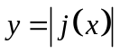
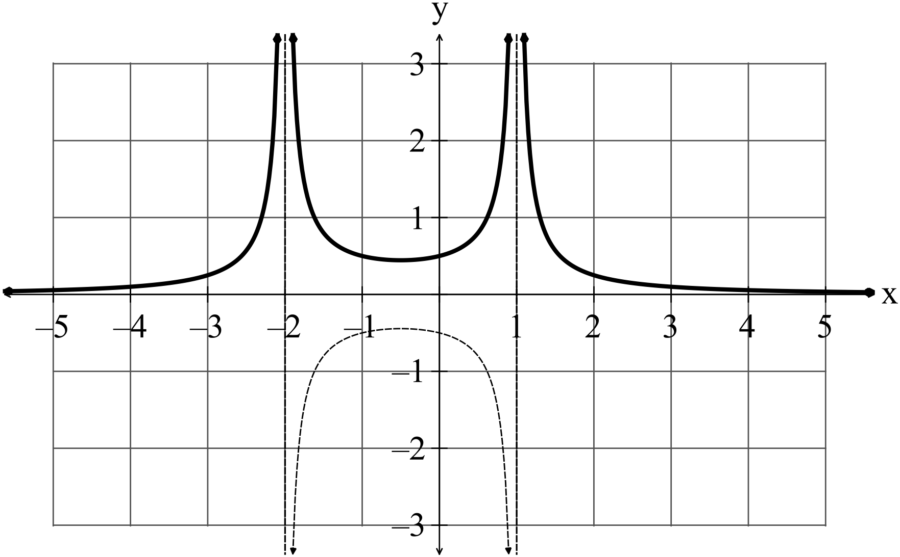
✓✓

(2)
(iii) 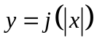
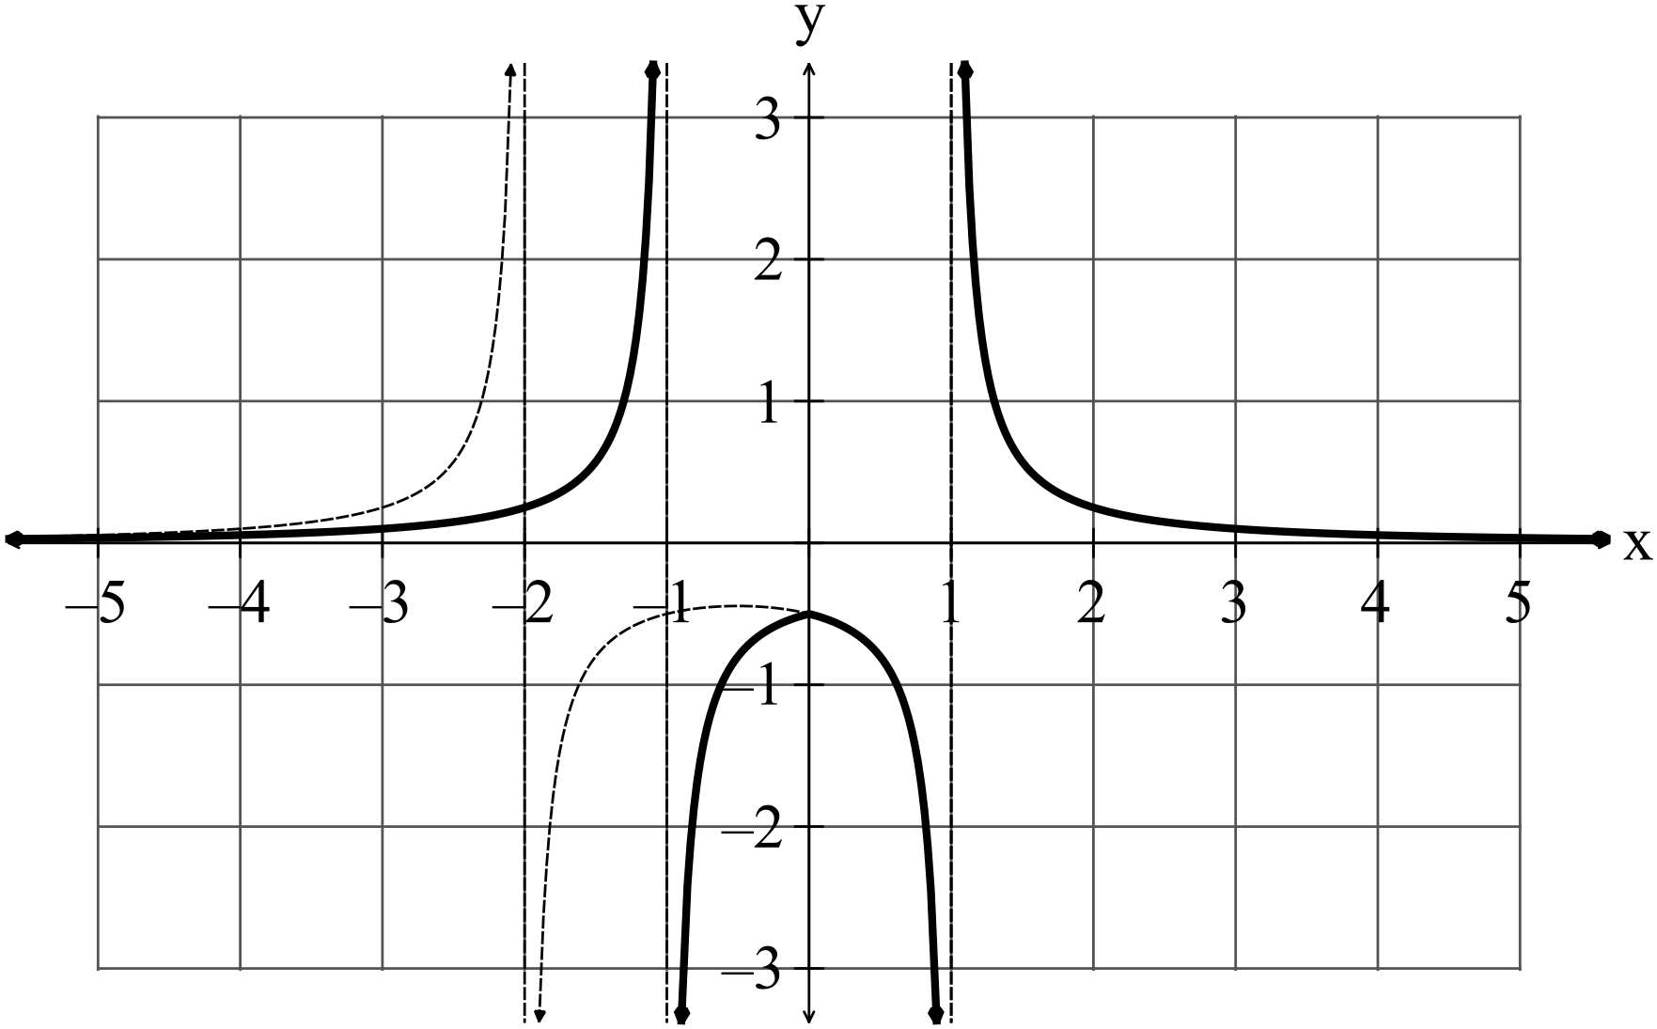
✓✓

(2)
(c) 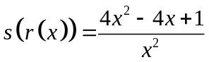
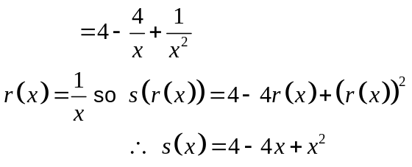
✓
✓
✓
(3)
14. (6 marks)
(a) 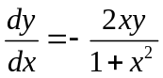
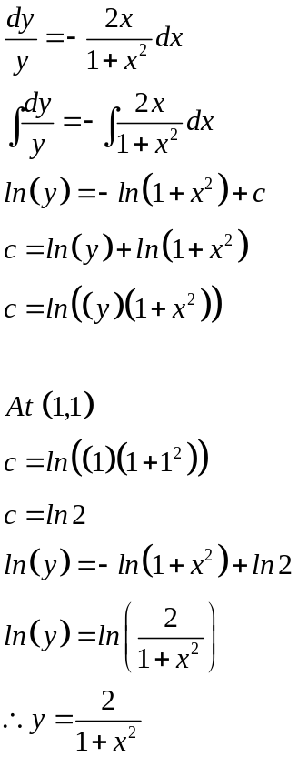
✓
✓
✓
✓
(4)
(b)
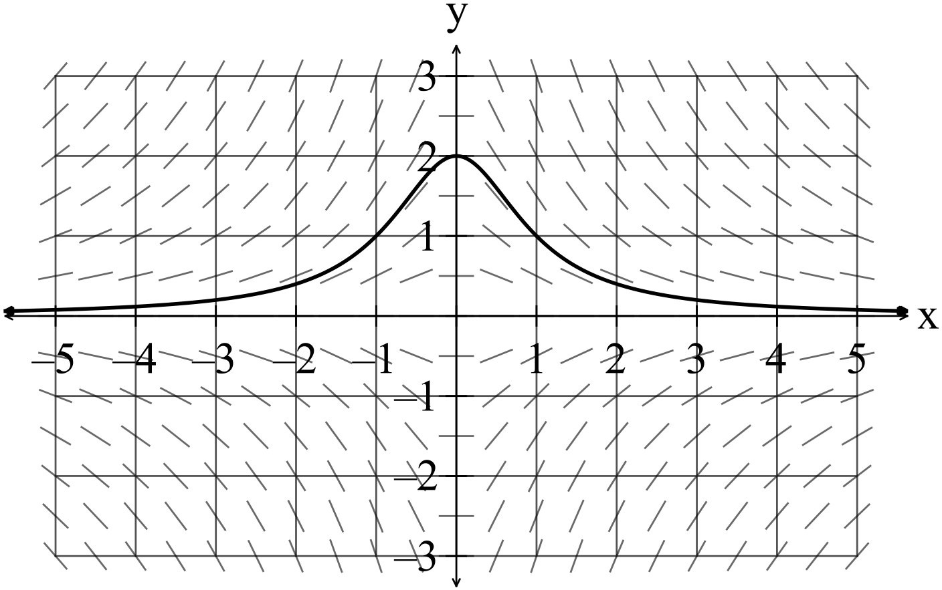
✓✓

(2) (3) (3)
✓
15. (7 marks)
(a) 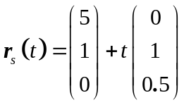
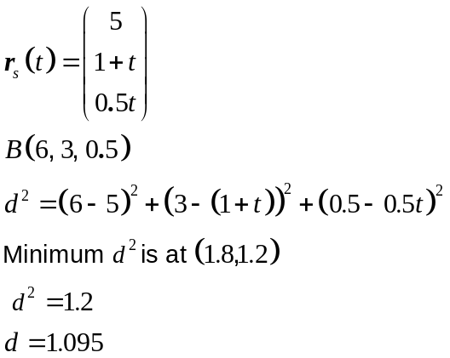
✓
✓
✓
The salmon is a minimum of 1.095 m from the bear (so it escapes). (3)

(b) 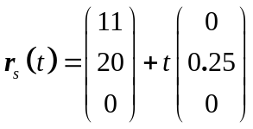
✓
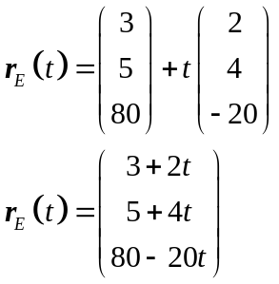
✓
If 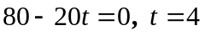
✓
It takes 4 seconds for the eagle to reach ground level.
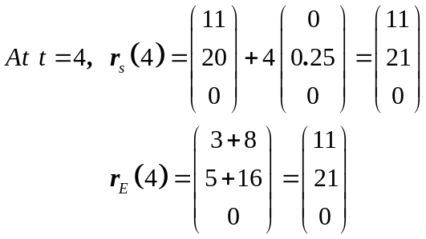
The salmon and the eagle are at the same place at the same time.
✓
Yes, the eagle catches the salmon.
(4)
16. (86 marks)
(a)
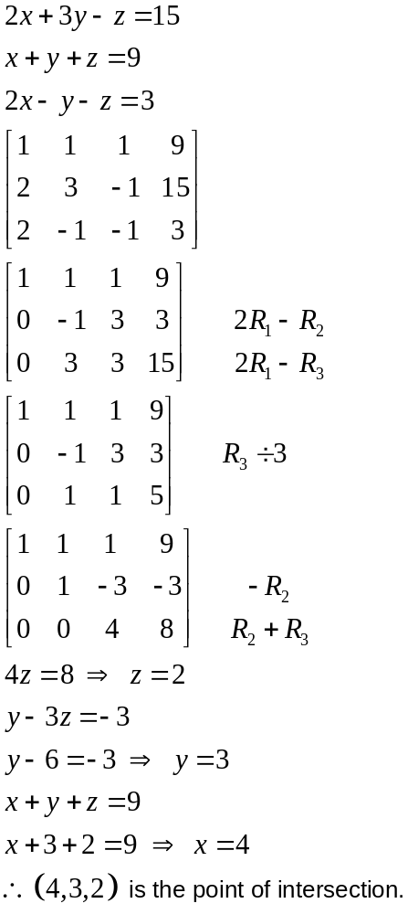
✓
✓
✓
✓
(4)
(b) 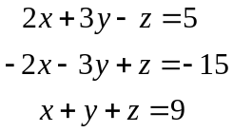

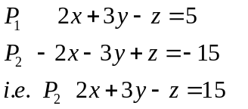
✓

✓
Which means 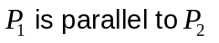so there are no solutions. (2)
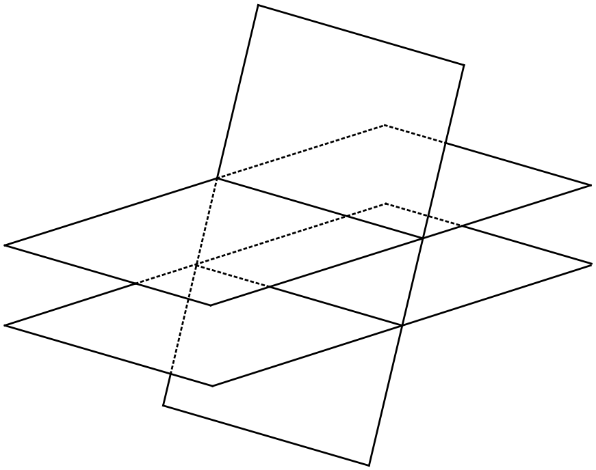
17. (8 marks)
(a) (i) The sampling distribution is normally distributed. ✓✓ (2)

(ii) Each sample has a mean. The distribution of the means approximates the
true mean and the distribution has a small standard deviation because the
mean of each sample approximates the mean itself.
The average of the means is a good estimate of the true mean. ✓✓ (2)

(iii) Each sample has a mean that approximates the true mean.
The mean of the samples, used as a sampling distribution, reduces the
variation of the sampling points. The means of the samples would be
similar to each other, so the standard deviation of the sampling distribution
will have a very small standard deviation compared to the parent population. ✓✓ (2)

(b) 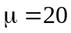 ✓
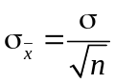
✓
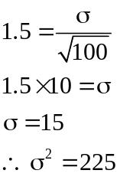
✓
(2)

18. (8 marks)
(a) 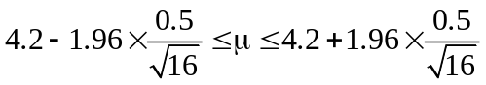
✓

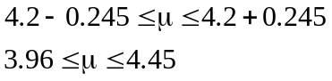
✓
✓

The biologist can be 95% confident that the average weight of the Chandler
✓
Road adult male quokkas is between 3.96 and 4.45 kgs.
If the sampling is repeated, 95% of the confidence intervals contain the mean weight.
✓

(4)

(b)
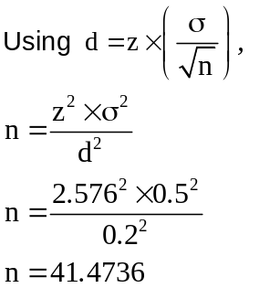
✓
✓
✓
The biologist would need to weigh 42 adult male quokkas to be 99% sure the
mean weight was within 0.2 kilograms of the true mean.
. (4)

19. (10 marks)
(a) 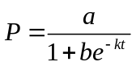
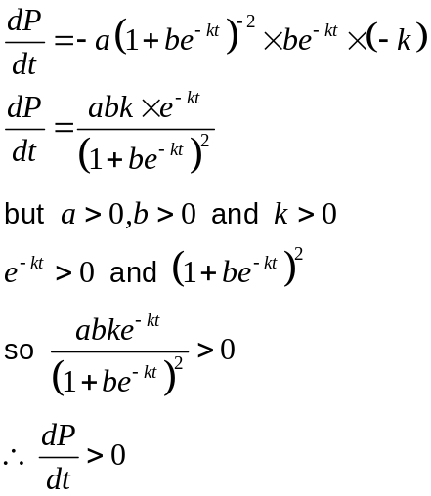
✓
✓
✓
(3)
(b) (i)
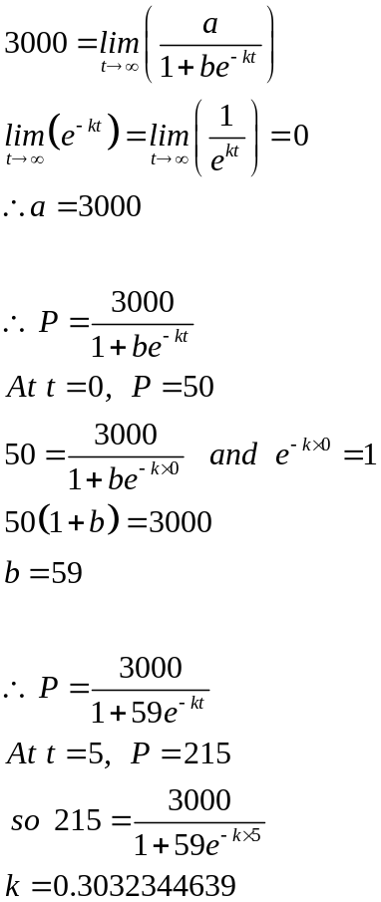
✓
✓
✓
✓
✓

(5)

(ii) 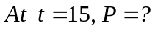
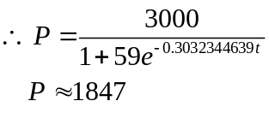
✓
(1)

END OF SECTION TWO

